**Group Theory Questions**

1. Show that (N, +) is a semigroup
2. Show that (N, ×) is a semigroup
3. Show that (N, ×) is a monoid
4. Show that (N, +) is not a monoid
5. Let *S = {a, b, c, d}. The multiplication tables in following Fig. define operations ∗ and ・ on S.*

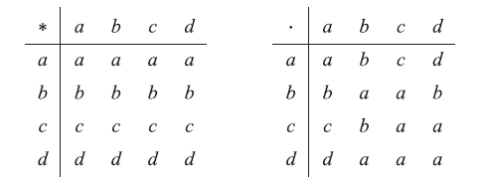

Check whether (S, ∗) is a semigroup

Check whether (S,.) is a semigroup

1. Show that the set G = {0,1,2,3,4,5} is an abelian group with respect to addition modulo 6.
2. The set G = {1,2,3,4,5,6} is an abelian group with respect to multiplication modulo 7
3. Show that  set of all non zero real numbers is an abelian group with respect to multiplication
4. Let (Z, *) be an algebraic structure, where Z is the set of integers and the operation * is defined by n * m = maximum of (n, m). Show that (Z, *) is a semi group. Is (Z, *) a monoid ?. Justify your answer.
5. Show that the set of all strings ‘S’ is a monoid under the operation ‘concatenation of strings’. Is S a group w.r.t the above operation? Justify your answer.
6. Show that the set of all positive rational numbers forms an abelian group under the composition * defined by a * b = (ab)/2 .
7. Show that G = {1, -1} is an abelian group under multiplication(x)
8. Show that G = {1, w, w2} is an abelian group under multiplication, where 1, w, w2 are cube roots of unity.
9. Show that G = {1, –1, i, –i } is an abelian group under multiplication.
10. Let I: set of integers,*is operation such that a*b=a+b+1, where a and b belongs to I. Prove that (I,*) is an abelian group.
11. Prove that the set, S= {0, 1, 2, 3, 4} is a ring with respect to the operation of addition and multiplication module 5 i.e. (+5 and X5)
12. If G = {1,-1,i,-i} is a group under multiplication, find the order of each element in the group.
13. If G = {0,1,2,3} is a group under addition modulo 4 find the order of 2 and 3.